- SQL Tasks

- Create Products table with product_id as PRIMARY KEY, price and category columns, and insert 6 records.
Input :
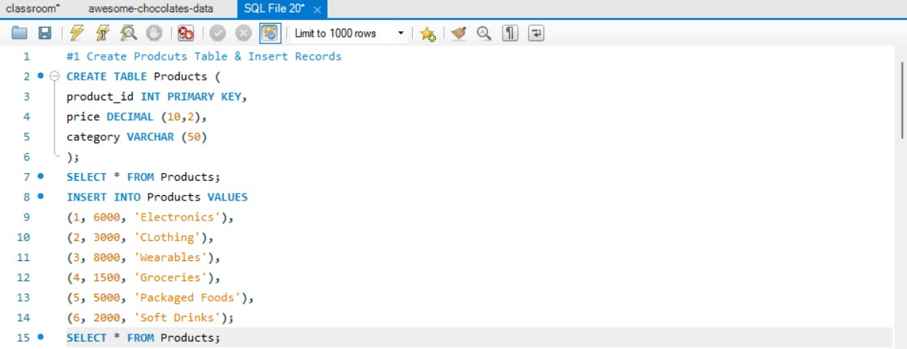
Output :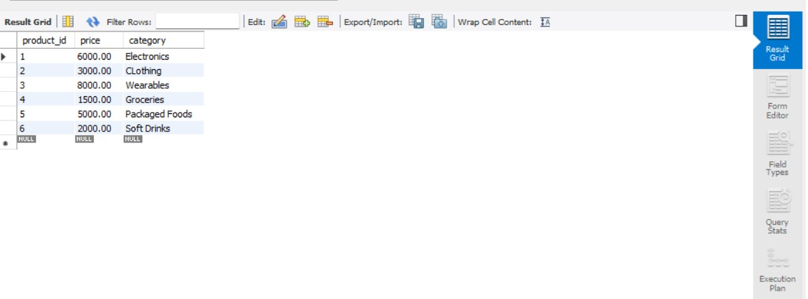
What we understood:
We learned how to:
- Create a table in SQL
- Define a Primary Key (unique identifier)
- Store structured data like product price and category
What logic is behind:
- A table is like an Excel sheet
- Primary Key ensures each row is unique (no duplicates)
- Columns define what type of data we store (price, category)
- Inserting records means adding rows into the table

- Create Orders table with order_id as PRIMARY KEY, product_id as FOREIGN KEY and quantity column.

Input :

Output :

What we understood:
We learned:
- How to connect two tables using a Foreign Key
- How relational databases work
What logic is behind:
- Foreign Key creates a relationship between tables
- product_id in Orders refers to product_id in Products
- This ensures:
  - Data consistency
  - No invalid product references
Example: You cannot order a product that doesn’t exist.

- Insert 5 order records linked with products.
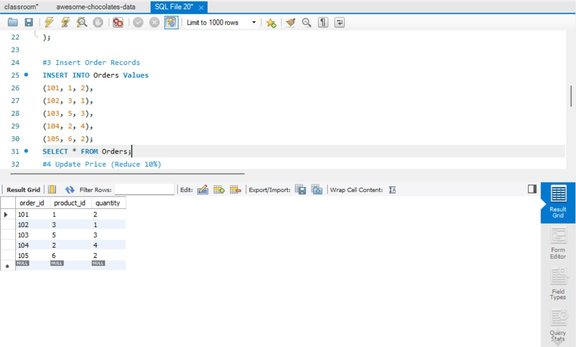
What we understood:
- How to insert multiple records into a table
- How linked data works between tables
What logic is behind:
- Each order must reference an existing product
- SQL enforces this using foreign key constraints
- This maintains data integrity

- Update price by reducing 10% where category = 'Electronics' AND price > 5000.
Input & Output :
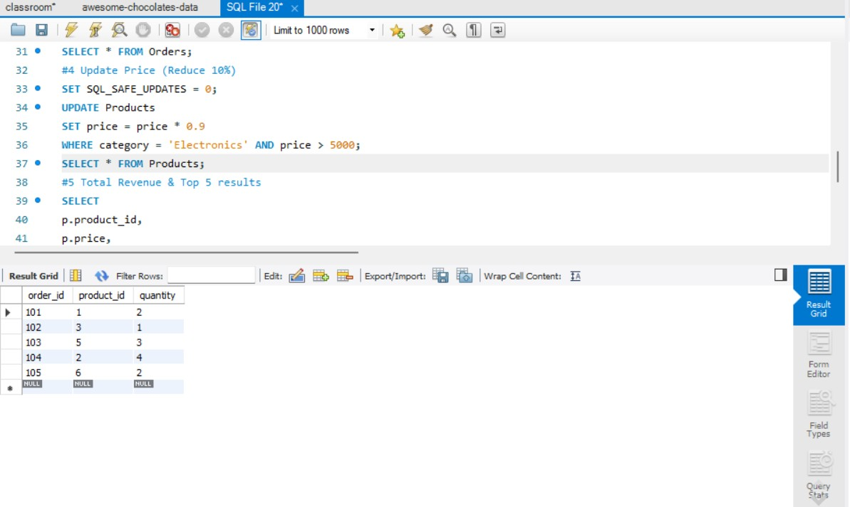
What we understood:
- How to update specific rows using conditions
- Use of WHERE, AND
What logic is behind:
- Condition:
category = 'Electronics'
AND price > 5000
- Only matching rows are updated
- New price = old price - 10%

- Retrieve total revenue (price * quantity) using aggregate function and display top 5 results using LIMIT.
Input & Output:
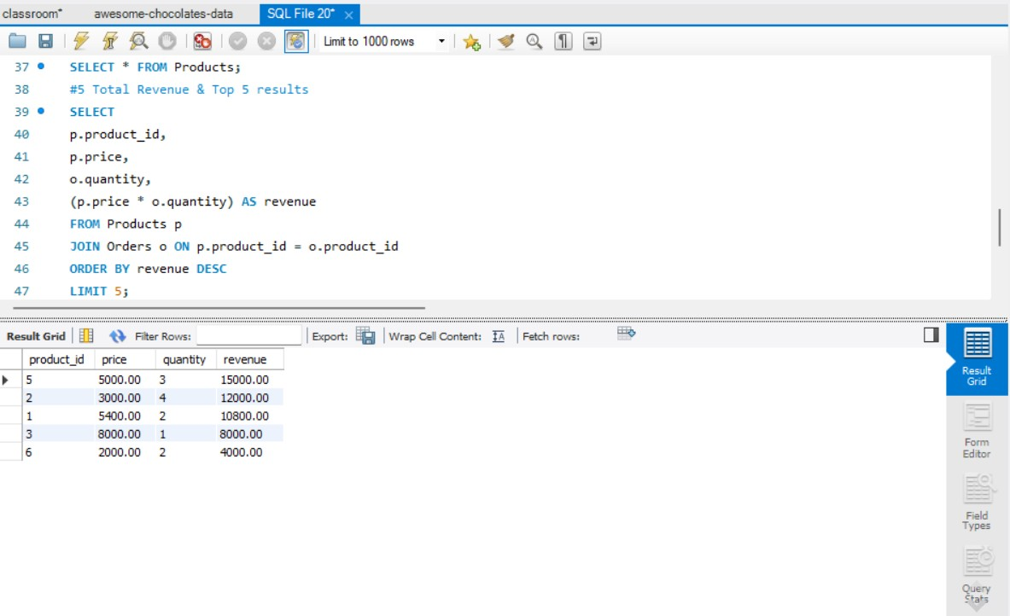
What we understood:
- Use of aggregate functions
- How to calculate revenue
- Use of LIMIT
What logic is behind:
- Revenue = price × quantity
- Use SUM() to calculate total revenue
- Use LIMIT 5 to get top results
SQL processes:
- Multiply columns
- Aggregate results
- Sort (if needed)
- Limit output

Python Tasks
- Ask user to enter username and password and allow login only if username == "admin" AND password == "1234".
Input & Output:

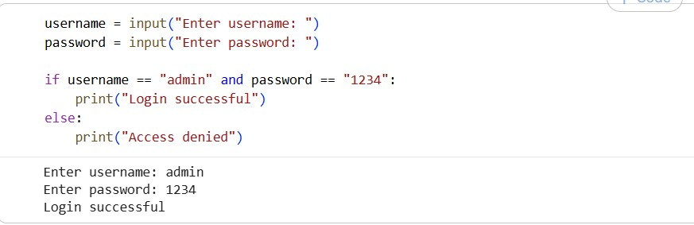
What we understood:
- Taking user input
- Using if condition with AND
What logic is behind:
- Check BOTH conditions:
username == "admin" AND password == "1234"
- If both true → allow login
- Else → deny access
Logical operator ensures strict validation

- Print multiplication table of a number using for loop.
Input & Output:

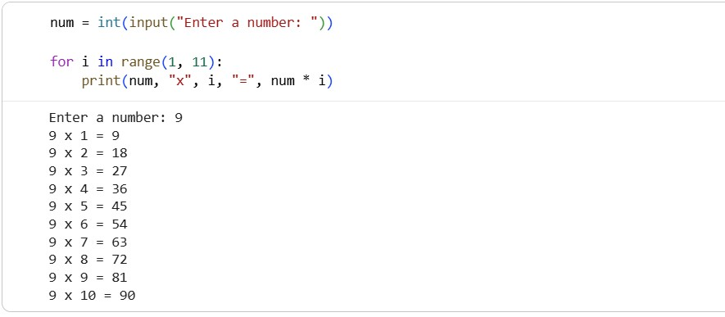
What we understood:
- How for loop works
- Repeating a task multiple times
What logic is behind:
- Loop runs from 1 to 10
- Multiply input number with loop variable

- Use while loop to keep taking input until user enters "exit".
Input & Output:
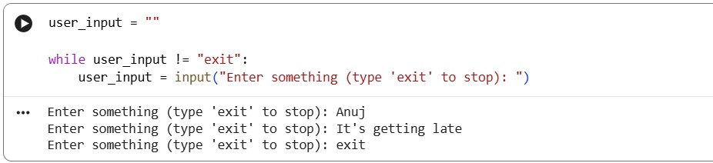
What we understood:
- Infinite loop concept
- Breaking loop using condition
What logic is behind:
- Loop keeps running until user types "exit"
- Condition checked every time

- Ask user for a number and print whether it is prime or not using if.
Input & Output :
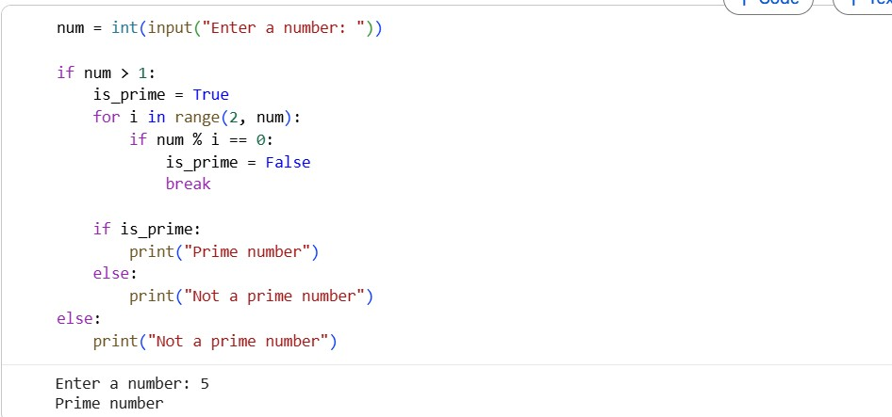
What we understood:
- How to use conditions (if)
- Basic number logic
What logic is behind:
- A prime number has only 2 factors: 1 and itself
- Check if number is divisible by any number between 2 and n-1
If divisible → not prime
Else → prime

- Take a string and print only uppercase characters using loop and condition.
Input & Ouput:
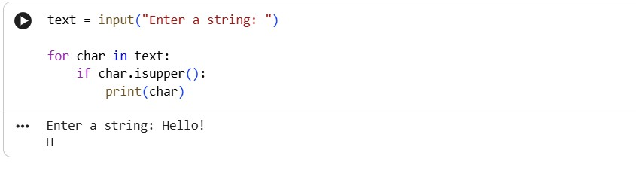
Print Uppercase Characters
What we understood:
- String iteration using loop
- Character checking
What logic is behind:
- Loop through each character
- Check condition:
if char.isupper()
- Print only uppercase letters
Example:
"Hello WORLD" → Output: H W O R L D

